**Native – iOS**

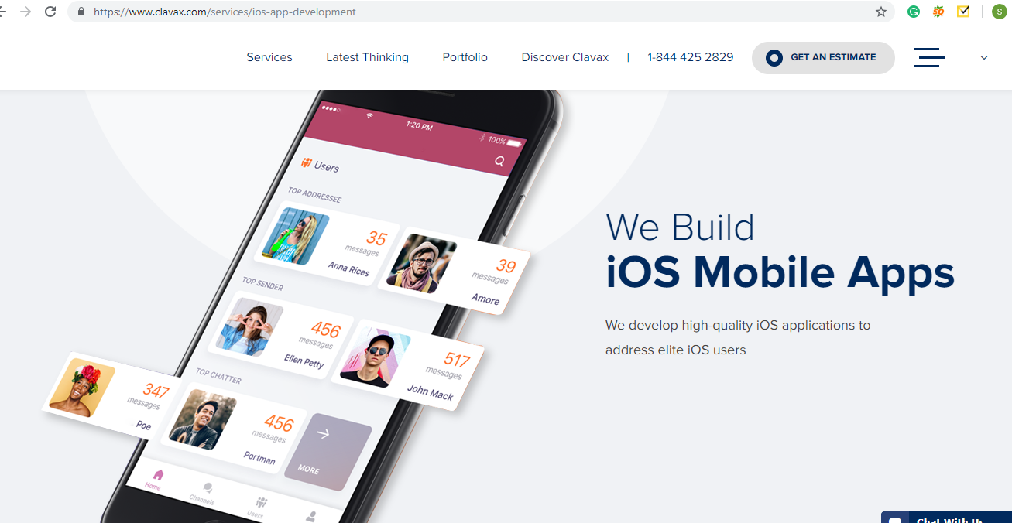

Building Top-Class apps with Elegant Interactions for iOS Devices

Next>>

Our iOS lifecycle right from designing to maintenance

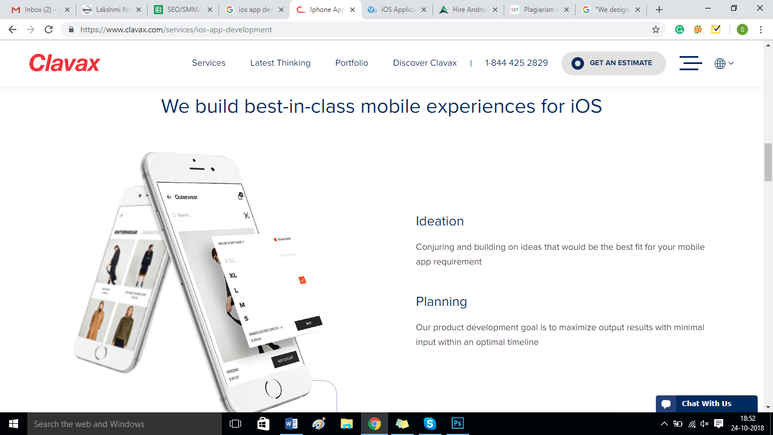

**Prototype Design**

We plan an early model or design to check the feasibility of the project and also to include the additional valued viewpoint of the client. Once deciding the essential layout, we start adding and implementing the animations and interactions by using apps such as Framer, Origami, etc. We try to add life to the jumbled design within the most inventive manner potential to boost user interaction.

**Code**

Our Developers are passionate who just know well, when where and how to give a twist to the design in order to reach the client’s prospects. Our developers get themselves trained in various languages to increase the efficiency of your project and aids you meet your customers’ expectations.

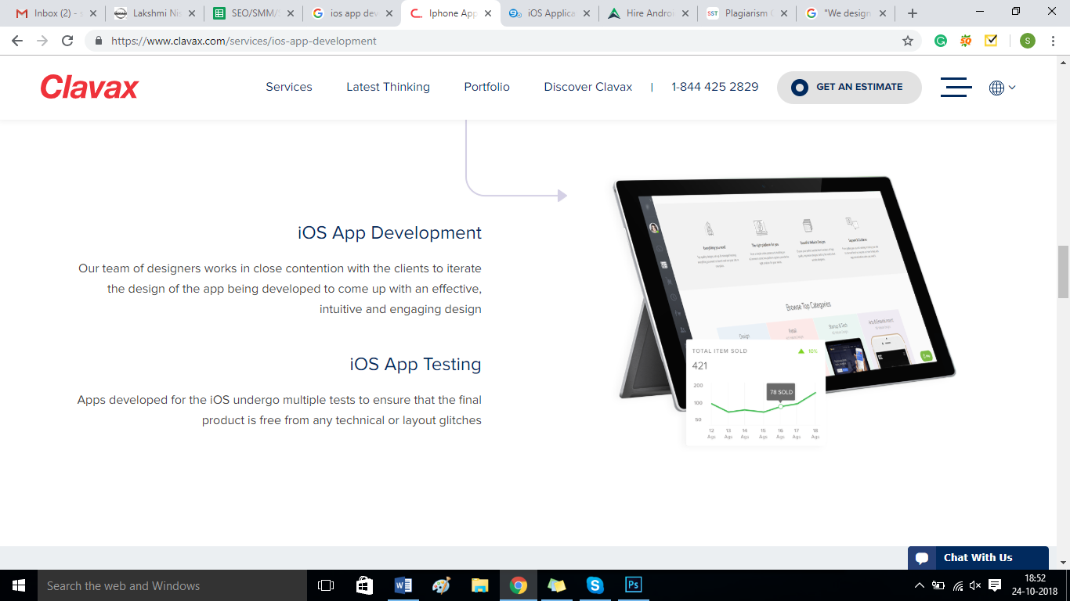

**Deliver:**

We value the time, hence never fail to deliver our quality product to our client on time. We include our client at every stage of development to have straightforwardness and least mistake. Therefore, we save our time as we lessen risk at the early stages of development.

Next>>

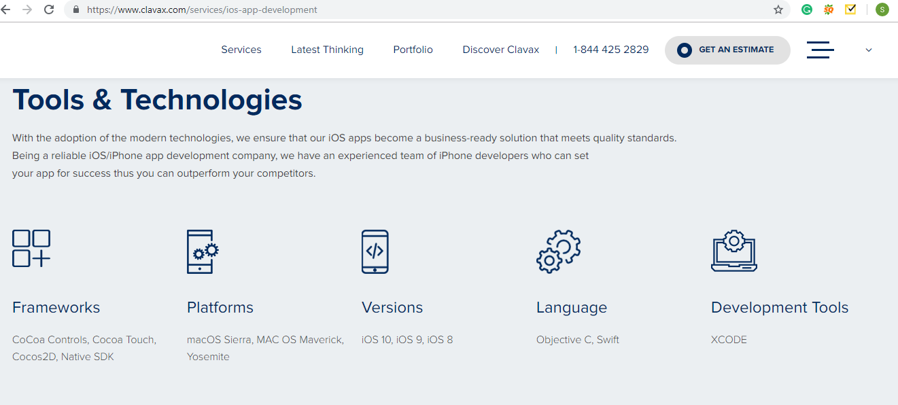

**Tools and Technologies**

With the embracing of the current technologies, we ensure that our iOS application becomes a business-ready solution that meets quality standards. Being a mobile application development company, we have an experienced team of iPhone developers who can set your application for success hence you can outstrip your competitors.

Next>>

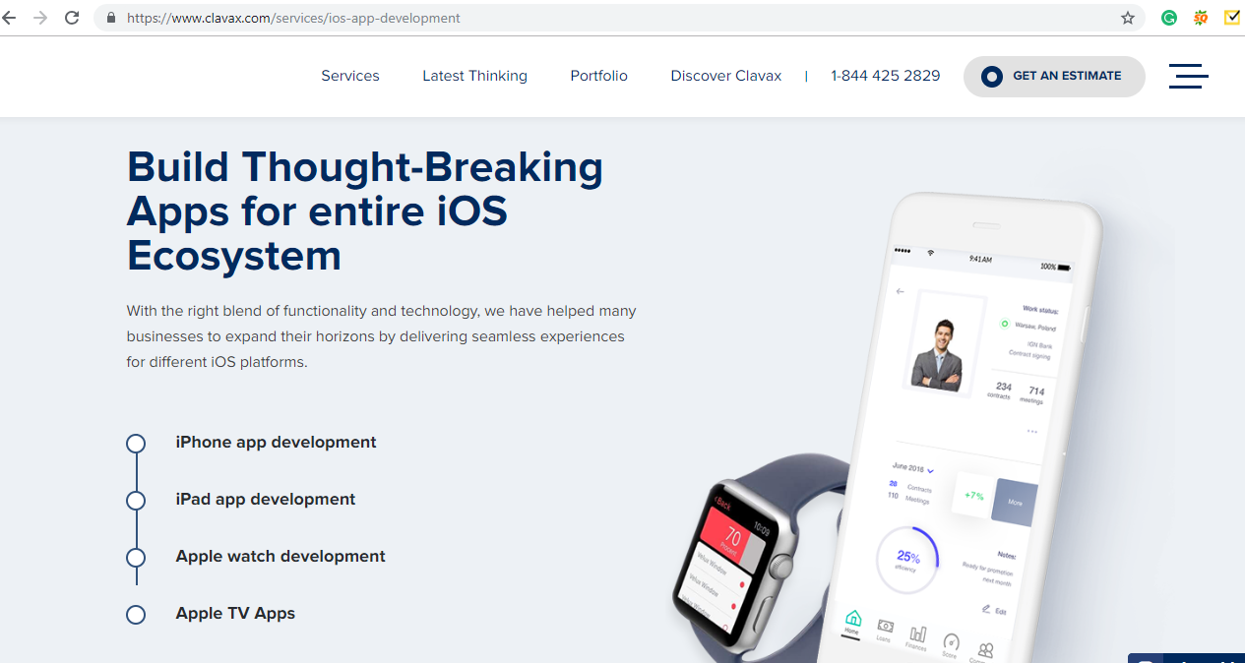

**Top-Notch Applications for entire iOS Platforms**

Nunc Systems helped numerous companies to increase their business by delivering unified experiences for different iOS platforms.

Next>>

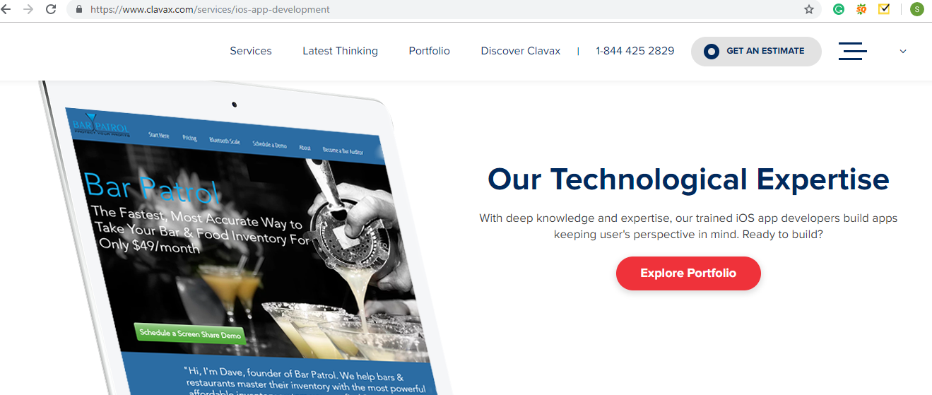

**Ready to Get Started?**

In the box use - Get Your Own Cavalry Today